Test Results

Origin City – Boston

Destination City – Newark

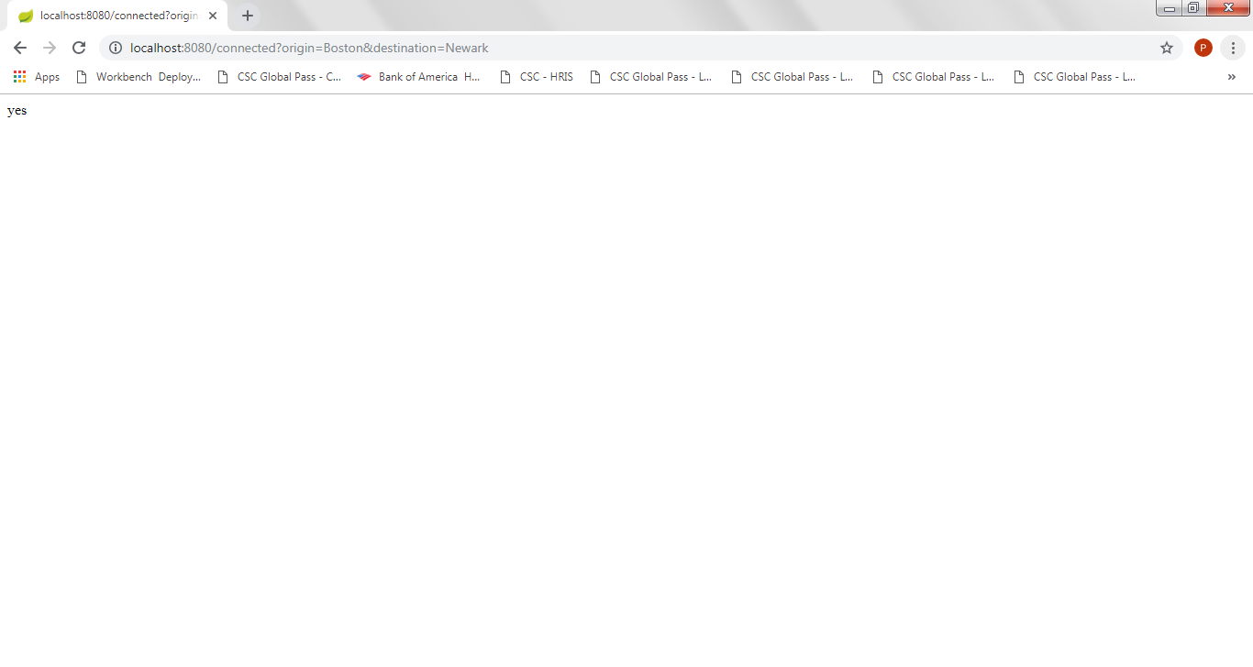

Origin City – Albany

Destination City – Philidelphia

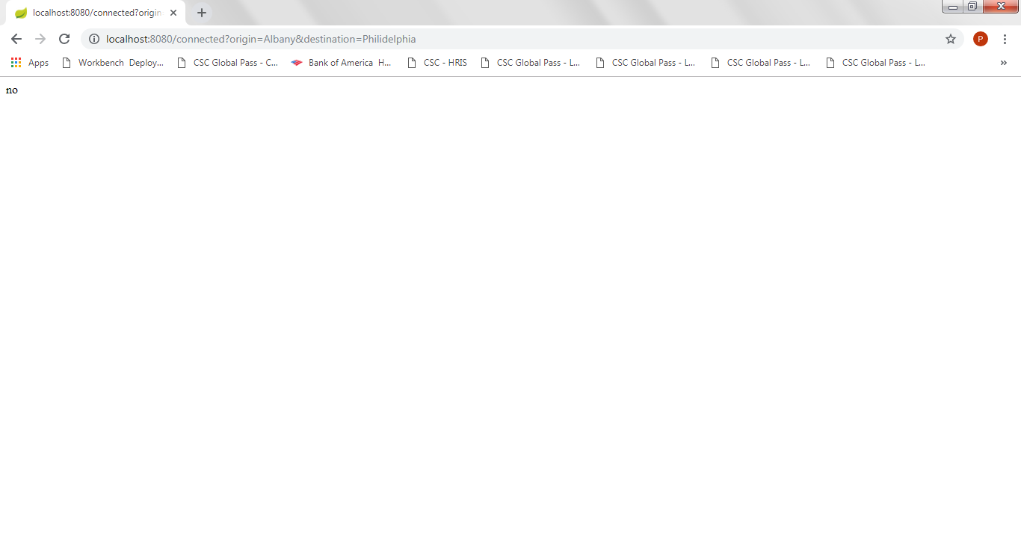

Origin City – Boston

Destination City – Unkown

